COMM 305 – Data Analytics
Requirements:
Power BI Build Checklist
Open OfficeHomeInc Data.xlsx (sheet: Transactions). Load to Power BI.

Create four visuals (one per CEO question), then a dashboard page with synchronized slicers.

SLICERS (put at top):
- YearMonth (Order Date 2), Region, Product Category, Country

Q1 — Total Sales by Country (Canada vs United States)
- Visual: Clustered column chart
- Axis: Country (filter to Canada, United States)
- Values: Sum of Sales
- Data labels: on; thousands separator; title: "Total Sales by Country: Canada vs United States"

Q2 — Sales & Contribution Margin over Time by Region
- Visual: Line chart (2 measures) or combo chart
- Axis: Month (from Order Date 2 -> YearMonth)
- Legend: Region
- Values: Sum of Sales; Sum of Contribution Margin $ (second series)
- Formatting: Sales solid lines, CM dashed, legend bottom, title: "Sales & Contribution Margin by Region — Monthly"

Q3 — Low-volume customers
- Visual: Bar chart (horizontal)
- Axis: Customer Name
- Values: Sum of Quantity ordered
- Sort: Ascending by Quantity; Top N -> show bottom 10 (use "Show items with value" filter or TopN + ascending)
- Title: "Bottom 10 Customers by Total Quantity"

Q4 — Ship mode mix by product sub-category
- Visual: 100% stacked bar chart
- Axis: Product Sub-Category
- Legend: Ship Mode
- Values: Count of Order ID
- Title: "Shipping Mode Mix by Product Sub-Category"

Dashboard Page
- Place all four visuals in a 2x2 grid
- Add slicers (YearMonth, Region, Product Category, Country) and link to all visuals (Sync slicers -> All pages or this page)
- Add two buttons: "Reset Filters" (Bookmark -> Data) and "Show All Regions" (clears Region slicer)
- Background: light neutral; consistent fonts; data labels on where useful

CEO Question 1
How much sales do we generate in Canada and in the United States?
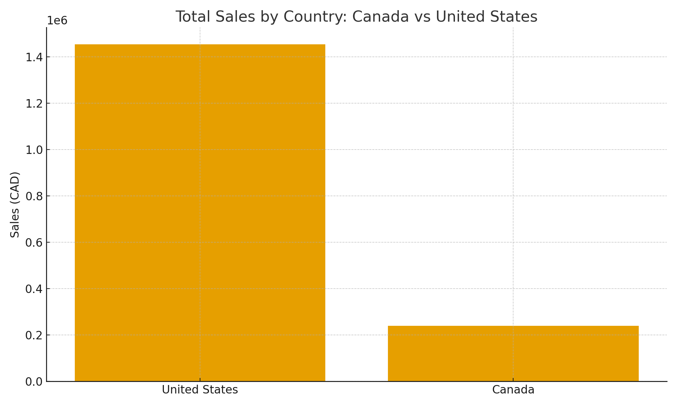
The What: Canada $240,438; US $1,454,904.
So What: The U.S. is the larger market by absolute sales; allocate resources accordingly while nurturing Canada for balanced growth.
Now What: Reallocate ~10–15% more marketing & inventory toward the U.S. growth categories; pilot targeted promotions in Canada.
How to Implement: Set monthly ROI reviews with country KPIs and codified reallocation rules in planning.

CEO Question 2
How much sales and contribution margin are we generating in each region over time?
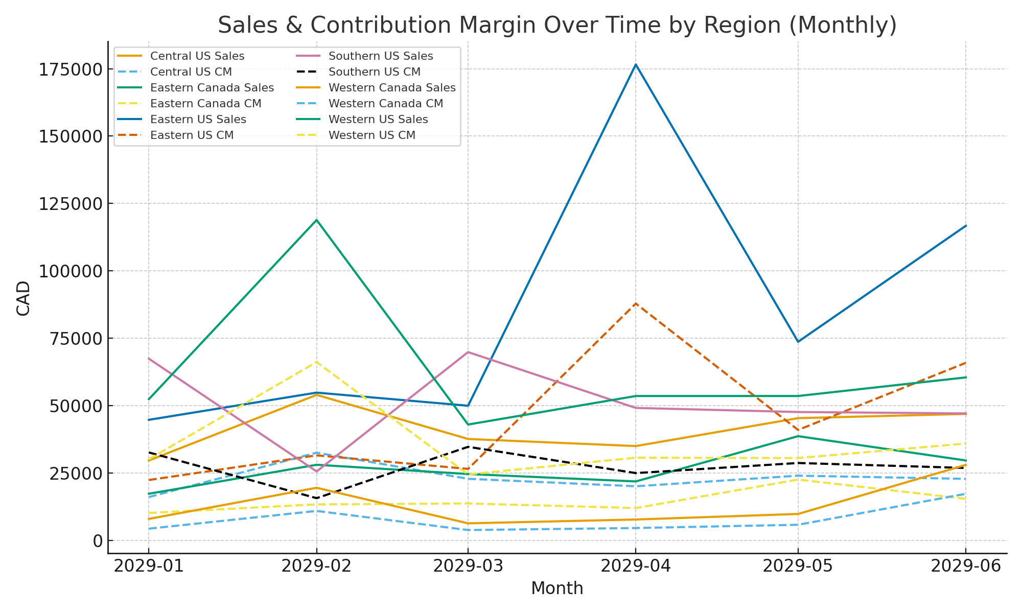
The What: Sales and contribution margin trend together across regions; West and East are strongest with clear seasonal peaks.
So What: Staffing, inventory, and promotions should follow regional seasonality and focus on CM uplift, not only revenue.
Now What: Build a rolling 3‑month forecast by region, linking promotions to CM targets and expected uplift.
How to Implement: Create a Power BI forecast page with region slicers and monthly CM targets monitored at month‑end.

CEO Question 3
Who are our low-volume customers?
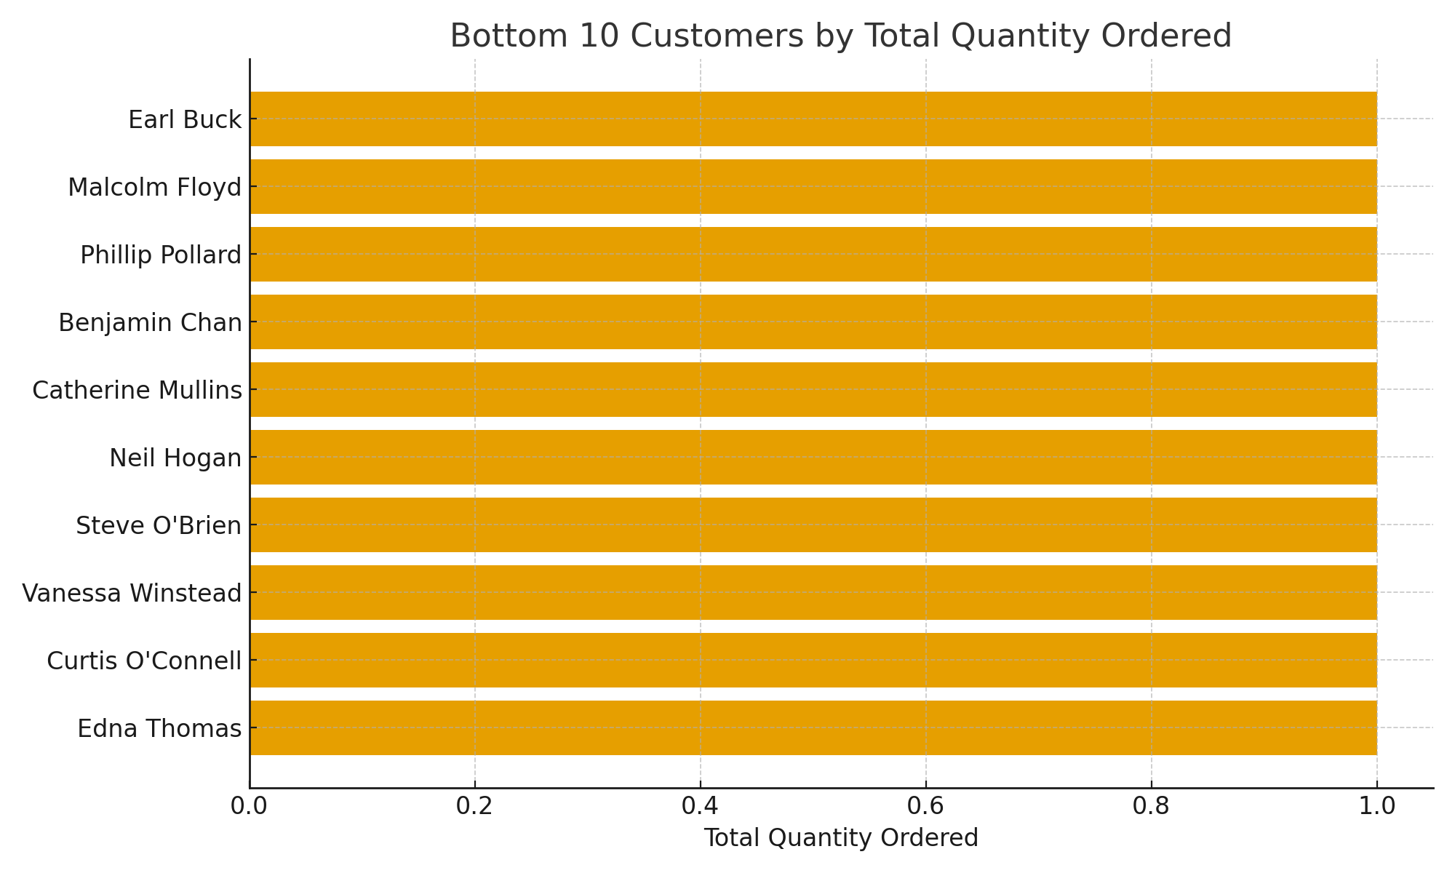
The What: Bottom 10 customers by total quantity — Edna Thomas (1); Curtis O'Connell (1); Vanessa Winstead (1); Steve O'Brien (1); Neil Hogan (1); Catherine Mullins (1); Benjamin Chan (1); Phillip Pollard (1); Malcolm Floyd (1); Earl Buck (1).
So What: These accounts contribute minimal volume; direct sales effort selectively to upsell-ready ones and move the rest to light-touch.
Now What: Split into (a) growth‑potential segment for cross‑sell and (b) maintain segment on a low‑touch cadence; assign owners.
How to Implement: Run a 4‑email + SDR follow‑up sequence for growth segment; newsletter‑only for others; track 90‑day lift.

CEO Question 4
What is the mix of shipping modes used per product sub‑category?
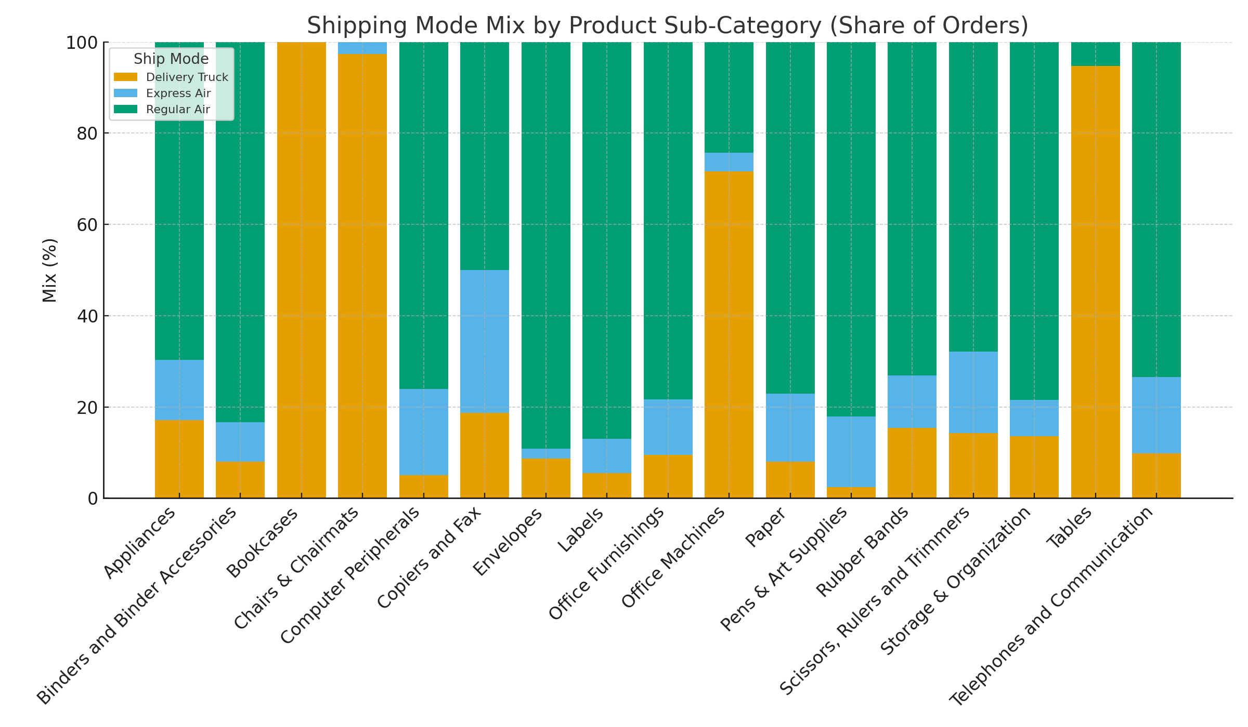
The What: Dominant ship mode by sub‑category — Appliances: Regular Air (70%); Binders and Binder Accessories: Regular Air (83%); Bookcases: Delivery Truck (100%); Chairs & Chairmats: Delivery Truck (97%); Computer Peripherals: Regular Air (76%); Copiers and Fax: Regular Air (50%); Envelopes: Regular Air (89%); Labels: Regular Air (87%); Office Furnishings: Regular Air (78%); Office Machines: Delivery Truck (72%); Paper: Regular Air (77%); Pens & Art Supplies: Regular Air (82%); Rubber Bands: Regular Air (73%); Scissors, Rulers and Trimmers: Regular Air (68%); Storage & Organization: Regular Air (78%); Tables: Delivery Truck (95%); Telephones and Communication: Regular Air (73%).
So What: Mode preference varies by product type; right‑size service levels to reduce cost and maintain delivery speed.
Now What: Align carrier contracts to actual usage and pilot mode downgrades where service is over‑specified.
How to Implement: Set mode‑mix targets by sub‑category; track monthly variance and trigger reviews when deviation exceeds 5pp.

Dashboard
